Balancing your ideas and your sources

Too much information from sources

Grandpa Patrick Walsh told many stories that describe the details of a firefighter's life. One memory he shared was of fighting fires with a fire engine drawn by a team of horses (Jones, 2014).  “A fire horse was a dedicated creature, and it was always a sad event in any company when a veteran steed was forced to retire” (West, 2011, p. 131).   A firefighter in New York City in the 1920s spent nine of 10 days on the job.  Day number 10 was for catching up with family, friends, and neighbors (West, 2011).  “Firefighters were often inspired to follow this career based on their own personal experiences” (Jones, 2014, p. 37).  In the 1920s, fires were both common and devastating in big cities. (West, 2011).

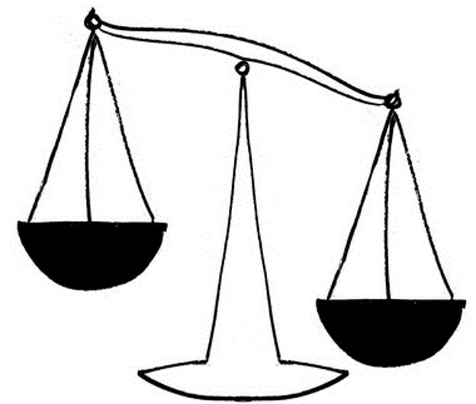

 “A fire horse was a dedicated creature, and it was always a sad event in any company when a veteran steed was forced to retire”

“Firefighters were often inspired to follow this career based on their own personal experiences.”

A firefighter in New York City in the 1920s spent nine of 10 days on the job.  Day number 10 was for catching up with family, friends, and neighbors.

One memory he shared was of fighting fires with a fire engine drawn by a team of horses.

**Information from**

**sources**

Your ideas

In the 1920s, fires were both common and devastating in big cities.

Grandpa Patrick Walsh told many stories that describe the details of a firefighter's life.

**MORE**

**The right balance between your ideas and information from sources**

Grandpa Patrick Walsh spent his days battling the city’s blazes in the 1920s.  He was a noted story-teller and shared many stories about fighting fires with fire engines drawn by a team of horses (A. Jones, 2014).  The horses were beloved for their fearlessness and dedication.   “A fire horse was a dedicated creature, and it was always a sad event in any company when a veteran steed was forced to retire” (West, 2011, p. 131).  Grandpa Walsh worked long hard days with few breaks, but this was typical.  A firefighter in New York City in the 1920s spent nine of 10 days on the job.  Day number 10 was for catching up with family, friends, and neighbors (West, 2011).  Interestingly, I was able to learn what inspired Grandpa Walsh to pursue this career.

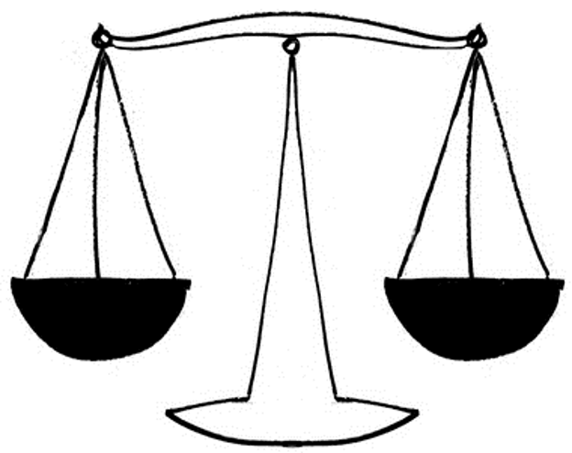

**Information from sources**

Your ideas

He was a noted story-teller and shared many stories about fighting fires with fire engines drawn by a team of horses.

 “A fire horse was a dedicated creature, and it was always a sad event in any company when a veteran steed was forced to retire”

A firefighter in New York City in the 1920s spent nine of 10 days on the job.  Day number 10 was for catching up with family, friends, and neighbors.

Grandpa Patrick Walsh spent his days battling the city’s blazes in the 1920s.

Grandpa Walsh worked long hard days with few breaks, but this was typical.

Interestingly, I was able to learn what inspired Grandpa Walsh to pursue this career.